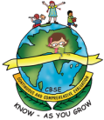
GREENWOOD PUBLIC SCHOOL
ADITYAPURAM, GWALIOR
SESSION 2024-25 : SYLLABUS FOR THE MONTH OF APRIL : CLASS-NURSERY
SUBJECTS | SYLLABUS | ACTIVITY + USE OF ICT | PARENTS INVOLVEMENT
ENGLISH  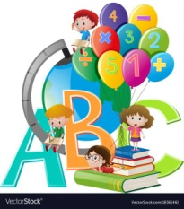  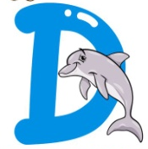  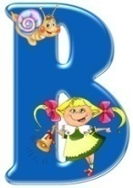  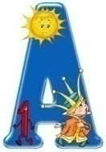 | ORAL:  Rhymes-  1. Twinkle-Twinkle…  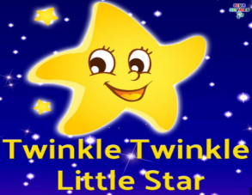  2. Johny-Johny…  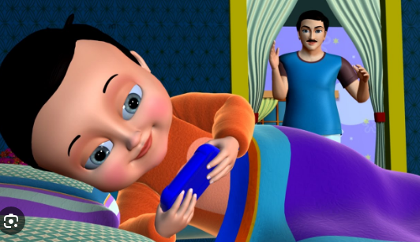  Sentence Structure- I am a boy/girl.  Vocabulary Building-  School, Bus, Bag, Book, Pencil, Eraser, Sharpener, Bottle, Lunch Box, Pencil Box  Recognition- A, B, C, D  WRITTEN:  Practicing Strokes- Standing lines, Sleeping lines, Slanting lines  Workbook- Page no. 5 to 8 | Rhymes- 1. Twinkle-Twinkle…  https://youtu.be/yCjJyiqpAuU?feature=shared  2. Johny-Johny…  https://youtu.be/EA_fbT6oN2k?feature=shared  Phonics Sound  https://www.youtube.com/watch?v=hq3yfQnllfQ  Alphabet Song  https://www.youtube.com/watch?v=zAlX1V3lK5s  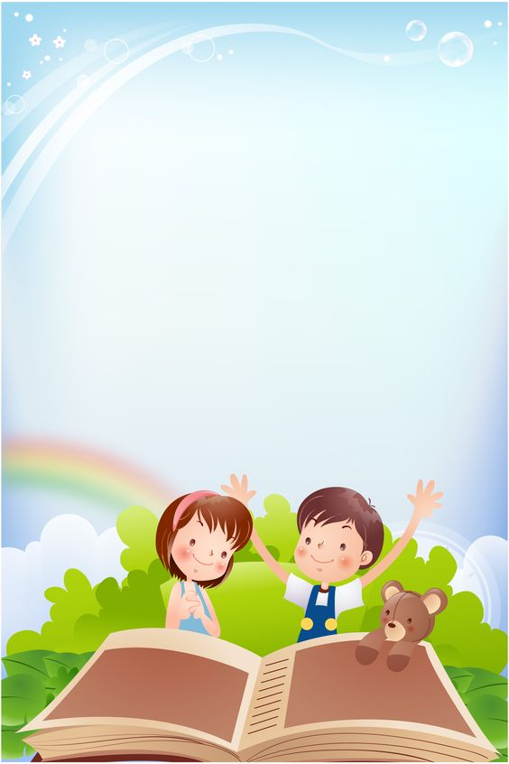  Activity Work  - ‘Look and Identify’ Game will be played for the recapitulation of the letters and their related objects. Learners will be asked to look and identify the objects as shown by the teacher.  - ‘Show and Tell’ Picture Reading Activity | - Play music and encourage your child to dance around. When the music stops, call out a word that rhymes with a simple action (e.g., "twinkle" and "papa"). Children freeze in place and perform the action associated with the rhyming word.  Vocabulary Building-  School,  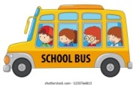  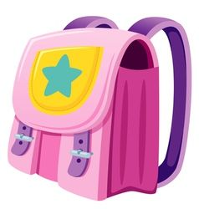  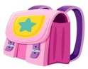  Bus,  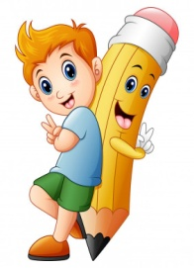  Bag,  Book,  Pencil,  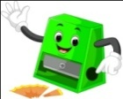  Eraser,  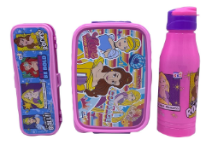  Sharpener  Bottle  Lunch Box  Pencil Box
SUBJECTS | SYLLABUS | ACTIVITY + USE OF ICT | PARENTS INVOLVEMENT
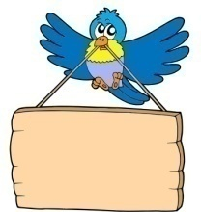  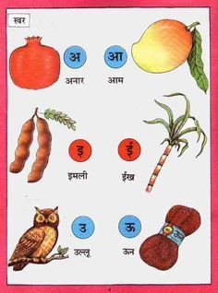  HINDI | ekSSf[kd%&  dfork,¡&  1- lwjt  2- eNyh  Loj o.kZ& v ls bZ rd  okD; jpuk& eSa ,d yM+dk@yM+dh gw¡A  v{kjksa dh igpku& v ls bZ rd  fyf[kr%&  lajpuk&vkM+h frjNh js[kk,¡] xksykdkj ,oa v)Zxksykdkj lajpuk,¡  v{kj ys[ku& ist ua- 5 ] 6 | dfork,¡&  1- lwjt  https://youtu.be/L8zLQymlXpU?feature=shared  2- eNyh  https://youtube.com/watch?v=4nvBAAl3RvY&feature=shared  Loj o.kZekyk xhr  https://www.youtube.com/watch?v=TM83zp1AkUM  Activity work  - dforkvksa dks lLoj okpu  - Þns[kks vkSj crkvksaÞ [ksy ls fp=ksa dks igpkudj crk,¡A | - cPpksa dks Lojksa ls lacaf/kr fp=@oLrq,¡ igpkuusa esa lgk;rk djsaA  - cPpksa dks dfork fofHkUu Hkkoksa rFkk eqnzkvksa lfgr ;kn djkus ds fy, çksRlkfgr djsaA
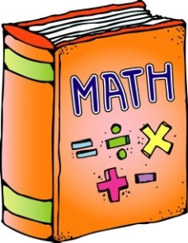 | ORAL:  1. Counting from 1-5  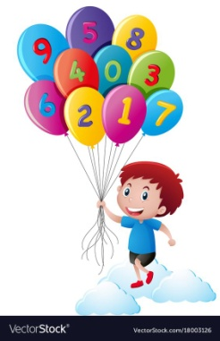  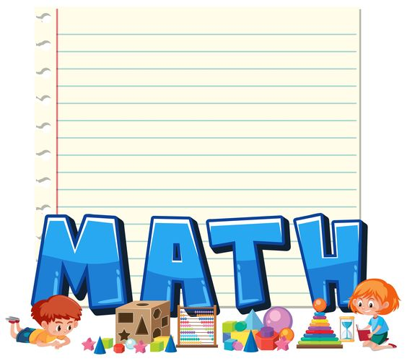  WRITTEN:  Standing lines,  Sleeping lines,  Slanting lines  Workbook-  Page no. 5 to 8 | Counting Song  https://www.youtube.com/watch?v=JT0MmZcJ2Vw  Activity Work  - ‘Look and Identify Number’ Game.  - Learners will be asked to count the objects asked by the educator. | - Provide a variety of toys or objects (e.g., blocks, stuffed animals). Ask your child to count the toys, group them by number, or sort them into containers labeled with numbers.

SUBJECTS | SYLLABUS | ACTIVITY + USE OF ICT | PARENTS INVOLVEMENT
ART & CRAFT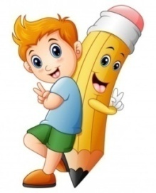 | Page no. 3,4,5,6  Craft- Finger Printing, Cotton Dabbing (Theme-Any Shape) | Introduction to Shapes through “Shapes song”  https://www.youtube.com/watch?v=QBD7CB-rroo  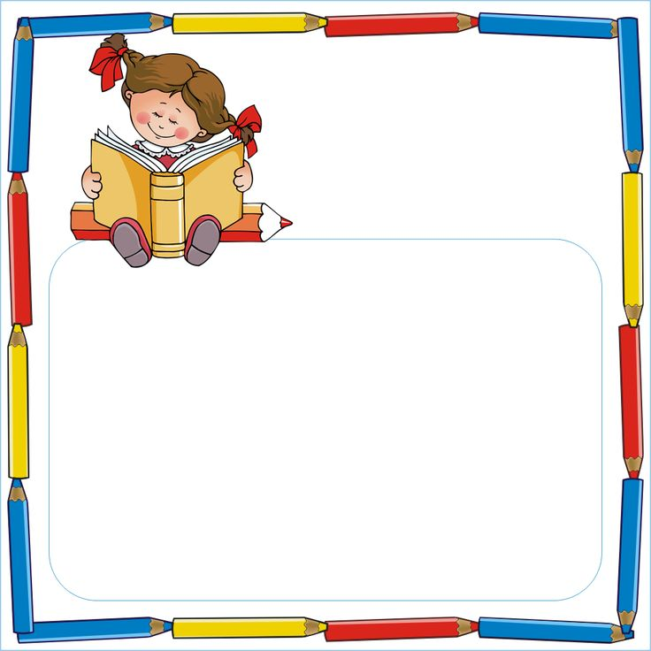  Activity Work  - ‘Look and Identify’ Shapes Game  - ‘Cut and Paste’ Game of different objects. | - Provide playdough and shape cutters in various shapes (e.g., circles, squares, triangles). Encourage your child to roll out the playdough and use the cutters to make shapes.
GENERAL KNOWLEDGE | My body- Ear, Eye, Nose, Hand, Fingers, Head, Mouth  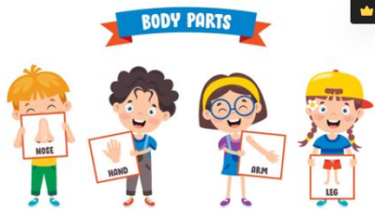 | Parts of the body  https://www.youtube.com/watch?v=SUt8q0EKbms  Activity Work  - Make a fruit chart pasting the  pictures of fruits. | - Sit in front of a mirror with your child and take turns mimicking each other's movements. Encourage them to point to and name the body parts they are moving.
VALUE EDUCATION | I love my parents. | Moral Story  https://www.youtube.com/watch?v=MEVyl3jq_3c | - Make your child learn the names of family members.
PHYSICAL EDUCATION | Fun Games- Running, Jumping, Hopping | DO EXERCISE THROUGH THIS LINK  https://www.youtube.com/watch?v=JoF_d5sgGgc | - Take your child to a park and play some games.
DANCE  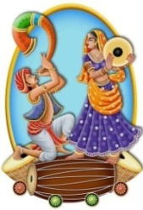 | 1. Shake your sillies out…  2. Boom Boom Dance.. | 1. Shake Your Sillies Out.. Song  https://youtu.be/NwT5oX_mqS0?feature=shared  2. Boom Boom Dance.. Song  https://youtu.be/6ZwbN0EVT2g?si=MOzZWaAmSHDt-sB5 | - Encourage your child to move specific body parts independently, such as wiggling fingers or shaking hips.
MUSIC | National Anthem, Gayatri Mantra,  Bhojan Mantra | https://www.youtube.com/watch?v=RqQ4asI70Bg  https://www.youtube.com/watch?v=SPm-Qy5m39E | - Practice the prayer regularly with your child to memorize it.
MOTOR SKILL DEVELOPMENT | 1. How to do Namaste  2. How to walk in a straight line  3. How to sit gracefully on the chair  4. How to use the washroom and wash hands | REFER THIS LINK  https://www.youtube.com/watch?v=wh6gt3IkRKk | - Encourage your child to run around in open spaces, either indoors or outdoors.
LANGUAGE DEVELOPMENT | This is my school.  I love my school. | MY SCHOOL- https://www.facebook.com/watch/?v=25316 31197059981 | - Make your child learn the name of school.
S.T.E.M. Fun | Melting Ice:  - Materials: Ice cubes, salt, small plastic toys  - Procedure: Place ice cubes in a container and sprinkle salt over some of them. Encourage children to observe and compare how the ice cubes melt with and without salt. Add small plastic toys to the ice cubes and observe how the melting ice affects them.

SUBJECTS | SYLLABUS | ACTIVITY + USE OF ICT | PARENTS INVOLVEMENT
CONVERSATION | ENGLISH CONVERSATION  1. What is your name?  Ans. My name is .  2. How are you?  Ans. I am fine, thank you.  3. How old are you?  Ans. I am 3 years old. | HINDI CONVERSATION  1- vkidk D;k uke gS\  m& esjk uke gSA  2- vki fdrus o’kZ ds gSa\  m& eSa rhu o’kZ dk gw¡A  3- vki dSls gS\  m& eSa vPNk@vPNh gw¡A | - Pay close attention to your child when he/she speaks, and respond with interest and enthusiasm. Ask open-ended questions and let the child respond.
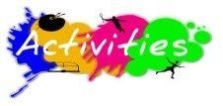 | Rhymes Recitation, Baisakhi Celebration, Earth Day Celebration- Handband Making using leaves
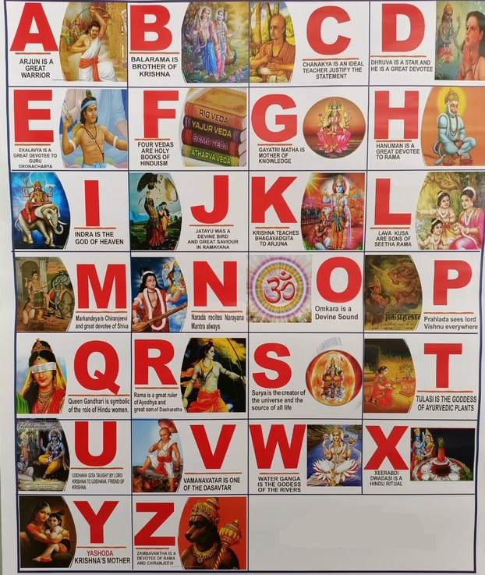
ALPHABETS

GREENWOOD PUBLIC SCHOOL
ADITYAPURAM, GWALIOR
SESSION 2024-25 : SYLLABUS FOR THE MONTH OF APRIL : CLASS-LKG
SUBJECTS | SYLLABUS | ACTIVITY + USE OF ICT | PARENTS INVOLVEMENT
ENGLISH | ORAL:  Rhymes-  1. Chubby Cheeks  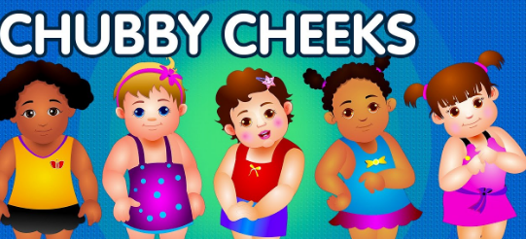  2. Humpty Dumpty  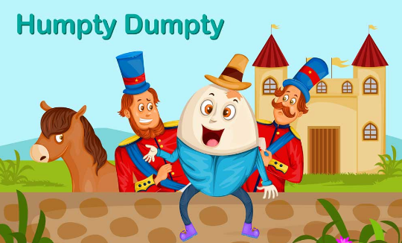  Reading- The Alphabets (A-Z), Vowels and Consonants, English Literacy Skills (Page no. 3-7)  Vocabulary Building- I, my, me, we, he, she, you, we, your and they  WRITTEN:  Capital Letters (A-Z),  Match the following,  Write the first letter of the picture,  Fill in the missing letters,  Circle the correct letter | Rhymes-  1. Chubby Cheeks  https://youtu.be/InjAIlwpdCQ?feature=shared  2. Humpty-Dumpty  https://youtube.com/watch?v=AIIj0mBX1jU&feature=shared  Phonics Sound  https://www.youtube.com/watch?v=hq3yfQnllfQ  Alphabet Song  https://www.youtube.com/watch?v=zAlX1V3lK5s  Vowels Song  https://www.youtube.com/watch?v=RUSCz41aDug  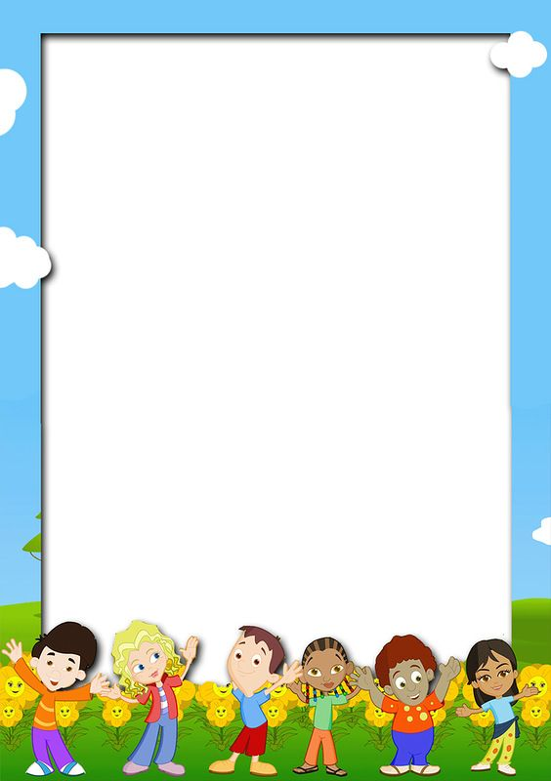  Activity Work  - ‘Look and Identify’ Game will be played for the recapitulation of the letters and their related objects. Learners will be asked to look and identify the objects as shown by the teacher.  - ‘Show and Tell’ Picture Reading Activity | 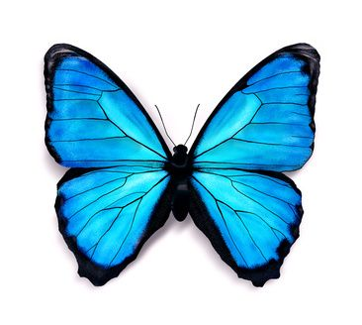  - Play music and encourage your child to dance around. When the music stops, call out a word that rhymes with a simple action (e.g., "Chubby" and "Humpty Dumpty"). Children freeze in place and perform the action associated with the rhyming word.
SUBJECTS | SYLLABUS | ACTIVITY + USE OF ICT | PARENTS INVOLVEMENT
HINDI | ORAL:  dfork,¡&  1- losjk 2- VsyhQksu  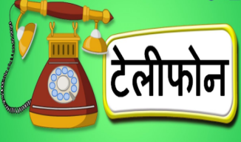  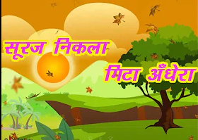  iBu&ikBu o.kZekyk& Loj ¼v ls v% rd½ vkSj  O;atu ¼d ls M+ rd½  'kCn lq/kk ist ua 3&6 rd  WRITTEN:  o.kZekyk& Loj ¼v ls v% rd½ vkSj  O;atu ¼d ls M+ rd½ tksM+h feykb,] fp= ns[kdj lgh v{kj ij xksyk yxkb,] fp= igpkudj izFke v{kj fyf[k,] [kkyh LFkku Hkfj,]  'kCn ys[ku ist ua&3&8 rd | dfork,¡&  1- losjk  https://www.youtube.com/watch?v=N2x3V-8CCzA  2- VsyhQksu  https://youtube.com/watch?v=DlDgnWFbs3Q&feature=shared  o.kZekyk  https://www.youtube.com/watch?v=GBWGNvHsiFs  Activity Work  - dforkvksa dks lLoj okpu  - ns[kks vkSj crkvksaÞ [ksy ls fp=ksa dks igpkudj crk,¡A  - ^ns[kksa vkSj crkvks* [ksy ds tfj, o.kksaZ dks igpkub, ,oa crkb,sA | - cPpksa dks O;atuksa ls lacaf/kr fp=@oLrq,¡ igpkuusa esa lgk;rk djsaA  - cPpksa dks dfork fofHkUu Hkkoksa rFkk eqnzkvksa lfgr ;kn djkus ds fy, çksRlkfgr djsaA
 | 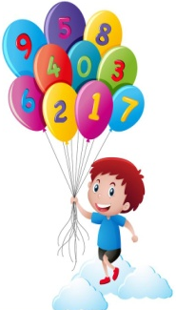  ORAL:  Counting- 1 to 30,  Table of 2,  Comparison-Big-Small,  Long-Short, Tall-Short,  Thick-Thin, In-Out  WRITTEN:  Counting from 1 to 30,  Count and write, Count & Match,  Fill in the missing numbers, Circle the correct numeral  Numeracy Skills Book page no.3-7 | Counting-  https://www.youtube.com/watch?v=B5iAW-jnkPw  Table of 2-  https://www.youtube.com/watch?v=VKJ9cCQgPdc  Opposite Words  https://www.youtube.com/watch?v=HGeuA4iJ8vI  ACTIVITY WORK  - Look and Identify Number Game.  - Learners will be asked to count the objects asked by the educator. | - Provide a variety of toys or objects (e.g., blocks, stuffed animals). Ask your child to count the toys, group them by number, or sort them into containers labeled with numbers.

SUBJECTS | SYLLABUS | ACTIVITY + USE OF ICT | PARENTS INVOLVEMENT
ART &  CRAFT  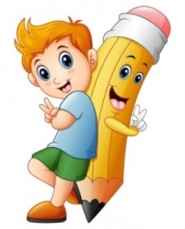 | Ball and Laptop (Page no. 2 & 3  Craft- Straw Hut, Origami Cat  (Theme-Shapes) | Introduction to Shapes through “Shapes song”  https://www.youtube.com/watch?v=QBD7CB-rroo  Activity Work  - ‘Look and Identify’ Shapes Game  - ‘Cut and Paste’ Game of different objects. | - Provide playdough and shape cutters in various shapes (e.g., circles, squares, triangles). Encourage your child to roll out the playdough and use the cutters to make shapes.
GENERAL KNOWLEDGE | Parts of the body,  My Family | Parts of the body  https://www.youtube.com/watch?v=SUt8q0EKbms  Activity Work  - ‘Cut and Paste’ Game through the pictures of Healthy & Unhealthy food. | - Sit in front of a mirror with your child and take turns mimicking each other's movements. Encourage them to point to and name the body parts they are moving.
VALUE EDUCATION | Always Speak the Truth | Moral Story  https://www.youtube.com/watch?v=MEVyl3jq_3c | - Make your child learn the names of family members.
PHYSICAL EDUCATION | Fun Games- Running, Jumping, Hopping | DO EXERCISE THROUGH THIS LINK  https://www.youtube.com/watch?v=JoF_d5sgGgc | - Take your child to a park and play some games.
DANCE | 1. Shake your sillies out…  2. Boom Boom Dance.. | 1. Shake Your Sillies Out.. Song  https://youtu.be/NwT5oX_mqS0?feature=shared  2. Boom Boom Dance.. Song  https://youtu.be/6ZwbN0EVT2g?si=MOzZWaAmSHDt-sB5 | - Encourage your child to move specific body parts independently, such as wiggling fingers or shaking hips.
MUSIC | National Anthem, Gayatri Mantra,  Bhojan Mantra | https://www.youtube.com/watch?v=RqQ4asI70Bg  https://www.youtube.com/watch?v=SPm-Qy5m39E | - Practice the prayer regularly with your child to memorize it.
MOTOR SKILL DEVELOPMENT | 1. How to do Namaste?  2. How to walk in a straight line?  3. How to sit gracefully on the chair?  4. How to use the washroom and wash hands? | REFER THIS LINK  https://www.youtube.com/watch?v=wh6gt3IkRKk | - Encourage your child to run around in open spaces, either indoors or outdoors.
LANGUAGE DEVELOPMENT | Action words :  Writing, Eating, Jumping, Running and drinking. | MY SCHOOL- https://www.facebook.com/watch/?v=25316 31197059981 | - Encourage your child in role-playing activities with action words like "fly like a bird," "roar like a lion," "swim like a fish," and "crawl like a bug."

SUBJECTS | SYLLABUS | ACTIVITY + USE OF ICT | PARENTS INVOLVEMENT
S.T.E.M. Fun | Melting Ice:  - Materials: Ice cubes, salt, small plastic toys  - Procedure: Place ice cubes in a container and sprinkle salt over some of them. Encourage children to observe and compare how the ice cubes melt with and without salt. Add small plastic toys to the ice cubes and observe how the melting ice affects them.
CONVERSATION | English Conversation  Q-1 What is your name?  Ans- My name is______.  Q-2 What is your Father’s name?  Ans- My Father’s name is__________.  Q-3 What is your Mother’s name?  Ans- My Mother’s name is__________.  Q-4 In which class do you study?  Ans- I study in Class L.K.G.  Q-5 How old are you?  Ans- I am__years old.  Q-6 What is the name of your Class teacher?  Ans- My Class teacher’s name is_________. | Hindi Conversation  1- vkidk D;k uke gS\  m& esjk uke ---------------- gSA  2- vkids ikik dk D;k uke gS\  m& esjs ikik dk uke ------------ gSA  3- vkidh eEeh dk D;k uke gS\  m& esjh eEeh dk uke Jherh ----------- gSA  4- vki fdl d{kk esa i<+rs gSa\  m& eSa d{kk L.K.G. esa i<+rk gw¡@i<+rh gw¡A  5- vki fdrus o’kZ ds gSa\  m& eSa ---- o’kZ dk@dh gw¡A | - Pay close attention to your child when he/she speaks, and respond with interest and enthusiasm. Ask open-ended questions and let the child respond.
 | Rhymes Recitation, Baisakhi Celebration, Earth Day Celebration- Crown Making with leaves
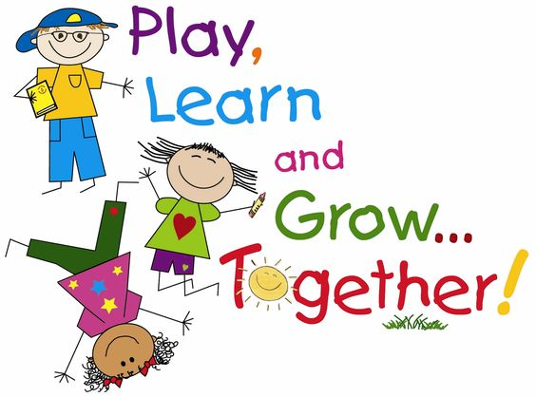
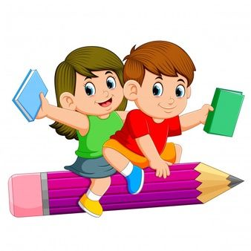
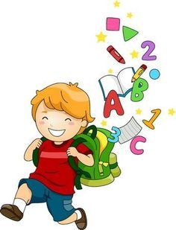

GREENWOOD PUBLIC SCHOOL
ADITYAPURAM, GWALIOR
SESSION 2024-25 : SYLLABUS FOR THE MONTH OF APRIL : CLASS-UKG
SUBJECTS | SYLLABUS | ACTIVITY + USE OF ICT | PARENTS INVOLVEMENT
ENGLISH | ORAL:  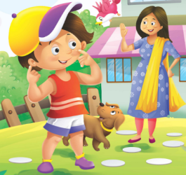  Rhymes-  1. My Body  2. My Mother  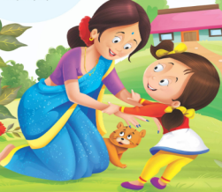  Sentence Structure-  1. I study in UKG class.  2. The name of my school is Greenwood Public School.  Reading (Phonics Skill Book)- A to Z, Vowels and Consonants, ‘a’ sound words, Page no. 5-7  Vocabulary Building- School, Classroom, Table, Chair and Black Board  WRITTEN:  Small Cursive Letters a-z, Capital Cursive Letters A-Z, Write the names of the given picture, Match the correct sound of the vowels with the picture | All Rhymes-  https://www.youtube.com/playlist?list=PL3zxtKnNCOvZhftg3R4pzG-UptEZL_t70  Phonics Sound  https://www.youtube.com/watch?v=hq3yfQnllfQ  Vowels Song  https://www.youtube.com/watch?v=RUSCz41aDug  Sound of ‘a’  https://www.youtube.com/watch?v=Sno15qcDEr4  Activity Work  - ‘Read and Tell’ Game will be played for the three letters words. Learners will be asked to read the words as shown by the teacher. | - Play music and encourage your child to dance around. When the music stops, call out a word that rhymes with a simple action (e.g., "My Body" and "My Mother"). Children freeze in place and perform the action associated with the rhyming word.
SUBJECTS | SYLLABUS | ACTIVITY + USE OF ICT | PARENTS INVOLVEMENT
HINDI | dfork,¡&  - ?kM+h 2- ckfj'k vkbZ  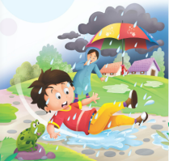  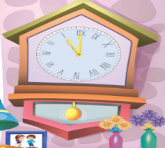  iBu ikBu&  ist ua 6 % vkvks nksgjk,¡ ¼Loj&v ls v% rd½  ist ua 7 % jax Hkfj,  ist ua 8 % O;atu vkvks nksgjk,¡  ist ua 9 % fp= ns[kdj v{kj ls feykb,  okD; jpuk& eSa ;w-ds-th- d{kk esa i<+rk@i<+rh gw¡A]  eSa xzhuoqM ifCyd Ldwy esa i<+rk@i<+rh gw¡A  fyf[kr%&  Loj o.kZ& v ls v% rd] O;atu& d ls K rd] nks v{kj okys “kCn fyf[k, | ckyxhr dfork,¡  https://www.youtube.com/playlist?list=PL3zxtKnNCOvZhftg3R4pzG-UptEZL_t70  o.kZekyk  https://www.youtube.com/watch?v=GBWGNvHsiFs  nks v{kj okys “kCn  https://www.youtube.com/watch?v=eiiahBq5Zt0  Activity Work  - dforkvksa dks lLoj okpu  - ns[kks vkSj crkvksaÞ [ksy ls fp=ksa dks  igpkudj crk,¡A  - ^ns[kksa vkSj crkvks* [ksy ds tfj, fcuk ek=k okys “kCnksa dks if<+, ,oa crkb,sA | - cPpksa dks fcuk ek=k okys “kCn dks i<+us esa lgk;rk djsaA  - cPpksa dks dfork fofHkUu Hkkoksa rFkk eqnzkvksa lfgr ;kn djkus ds fy, çksRlkfgr djsaA

SUBJECTS | SYLLABUS | ACTIVITY + USE OF ICT | PARENTS INVOLVEMENT
Numeracy & Skill book & Workbook | 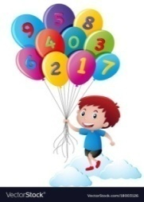  ORAL:  1. Counting from 1-100  2. Tables of 2 and 3  3. Number names from 1 to 20  4. Shapes  WRITTEN:  Counting from 1 to 100  Number names from 1 to 10  Backward Counting from 20-1  Tables of 2 and 3  Before, After and in Between  Count and Write  Matching Shapes | Counting-  https://www.youtube.com/watch?v=B5iAW-jnkPw  Table of 2-  https://www.youtube.com/watch?v=VKJ9cCQgPdc  Table of 3-  https://www.youtube.com/watch?v=v10unhK-3uU  Number Names  https://www.youtube.com/watch?v=LyvQ6pc7JSA  Activity Work  - ‘Look and Identify’ Number Game  - ‘Count and Tell’ Game. Learners will be asked to count the objects asked by the educator.  - ‘Dodging’ Game from the table of 2 and 3 | - Provide a variety of toys or objects (e.g., blocks, stuffed animals). Ask your child to count the toys, group them by number, or sort them into containers labeled with numbers.
EVS  General Awareness Skillbook  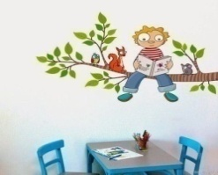 | ORAL:  1. Colours Names  2. Fruits Names  3. Body Parts  WRITTEN:  1. Colours Names  2. Fruits Names  3. Body Parts  (Tick the correct option, Matching, fill in the blanks) | Body Parts  https://www.youtube.com/watch?v=SUt8q0EKbms  Fruits Names  https://www.youtube.com/watch?v=DiV48J0uB_Y | - Sit in front of a mirror with your child and take turns mimicking each other's movements. Encourage them to point to and name the body parts they are moving.
ART & CRAFT | Page no. 3 to 5  (Colouring of Fruits, A Design, Lime Juice)  Craft- Straw Hut, Origami Cat  Theme-Shapes | Activity Work  - ‘Look and Identify’ Shapes Game  - ‘Cut and Paste’ Game of different objects. | - Provide playdough and shape cutters in various shapes (e.g., circles, squares, triangles). Encourage your child to roll out the playdough and use the cutters to make shapes.
GENERAL KNOWLEDGE | Fruits Names, Vegetables Names  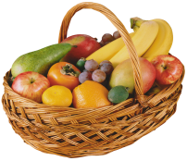 | Fruits Names  https://youtu.be/DiV48J0uB_Y  Activity Work  - Make a fruit chart pasting the  pictures of fruits. | - Take your child to a local fruit market where children can see a wide variety of fruits firsthand. Allow them to interact with vendors, ask questions and learn about different fruits.

SUBJECTS | SYLLABUS | ACTIVITY + USE OF ICT | PARENTS INVOLVEMENT
VALUE EDUCATION | Obey your elders | Moral Story  https://www.youtube.com/watch?v=ziXvFCKEGqM | - Tell any story to your child as a tool to convey the importance of obeying elders.
PHYSICAL EDUCATION | Fun Games- Running, Jumping, Hopping, Yoga | DO EXERCISE THROUGH THIS LINK  https://www.youtube.com/watch?v=JoF_d5sgGgc | - Take your child to a park and play some games.
DANCE  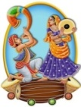 | 1. Shake your sillies out…  2. Boom Boom Dance.. | 1. Shake Your Sillies Out.. Song  https://youtu.be/NwT5oX_mqS0?feature=shared  2. Boom Boom Dance.. Song  https://youtu.be/6ZwbN0EVT2g?si=MOzZWaAmSHDt-sB5 | - Encourage your child to move specific body parts independently, such as wiggling fingers or shaking hips.
MUSIC | National Anthem, Gayatri Mantra,  Bhojan Mantra | https://www.youtube.com/watch?v=RqQ4asI70Bg  https://www.youtube.com/watch?v=SPm-Qy5m39E | - Practice the prayer regularly with your child to memorize it.
MOTOR SKILL DEVELOPMENT | 1. How to do Namaste  2. How to walk in a straight line  3. How to sit gracefully on the chair  4. How to use the washroom and wash hands | REFER THIS LINK  https://www.youtube.com/watch?v=wh6gt3IkRKk | - Encourage your child to run around in open spaces, either indoors or outdoors.
LANGUAGE DEVELOPMENT | Welcome to the class!,  Nice to meet you!,  Have a nice day! |  | - Encourage your child to engage in role-playing activities and act like different characters.
S.T.E.M. Fun | Melting Ice:  - Materials: Ice cubes, salt, small plastic toys  - Procedure: Place ice cubes in a container and sprinkle salt over some of them. Encourage children to observe and compare how the ice cubes melt with and without salt. Add small plastic toys to the ice cubes and observe how the melting ice affects them.
CONVERSATION | ENGLISH CONVERSATION  1. What is your name?  Ans. My name is .  2. What is your father’s name?  Ans. My father’s name is .  3. What is your mother’s name?  Ans. My mother’s name is .  4. How old are you?  Ans. I am … years old.  5.What is the name of your school?  Ans. The name of my school is Greenwood Public School. | HINDI CONVERSATION  1- vkidk D;k uke gS\  m& esjk uke gSA  2- vkids firkth dk uke D;k gSa\  m& vkids firkth dk uke Jh gSA  3- vkidh ekrkth dk uke D;k gSa\  m& vkidh ekrkth dk uke Jherh gSA  4- vki fdrus o’kZ ds gSa\  m& eSa o’kZ dk gw¡A  5- vkids fo|ky; dk D;k uke gS\  m& esjs fo|ky; dk uke xzhuoqM ifCyd Ldwy gSA | 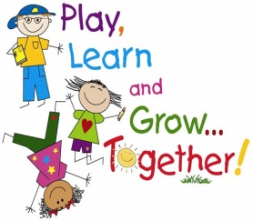  - Pay close attention to your child when he/she speaks, and respond with interest and enthusiasm. Ask open-ended questions and let the child respond.
 | Rhymes Recitation, Baisakhi Celebration, Earth Day Celebration- Crown Making with leaves

